PRACTICAL 8...

/* Program to search and modify contents of a file*/

#include<iostream.h>

#include<fstream.h>

#include<stdio.h>

class Employee

{

int Eno;

char Ename[25];

float Esalary;

public:

void output()

{

cout<<"Employee Number : ";

cout<<Eno<<endl;

cout<<"Employee Name : ";

puts(Ename);

cout<<endl;

cout<<"Employee salary : ";

cout<<Esalary<<endl;

}

void input()

{

cout<<"\nEnter employee number : ";

cin>>Eno;

cout<<"\nEnter employee name : ";

gets(Ename);

cout<<endl;

cout<<"\nEnter employee salary : ";

cin>>Esalary;

cout<<endl;

}

int getno()

{

return Eno;

 }

}emp;

int recordno(int);

int recordno(int temp_no)

{

fstream file;

file.open("Empc.txt",ios::in);

file.seekg(0,ios::beg);

int count=0;

while(file.read((char*)&emp,sizeof(emp)))

{

count++;

if(temp_no==emp.getno())

break;

}

file.close();

return count;

}

void main()

{

int ch;

cout<<"Menu \n";

cout<<"1. Search \n";

cout<<"2. Modify \n";

cout<<"Enter your choice : ";

cin>>ch;

cout<<endl;

switch (ch)

{

case 1:

{

int a;

fstream F;

Employee emp;

F.open("EMPc.txt",ios::in);

cout<<"Enter Number to be Searched for : ";

cin>>a;

F.read((char*)&emp,sizeof(emp));

while(F)

{

if(emp.getno()==a)

{

emp.output();

break;

}

else

F.read((char*)&emp,sizeof(emp));

}

F.close();

}

break;

case 2:

{

fstream f;

int location=0,temp_no=0,total=0;

f.open("Empc.txt",ios::in);

char ans;

cout<<"Enter employee code to modify";

cin>>temp_no;

total=recordno(temp_no);

location=(total-1)*sizeof(emp);

f.seekg(location);

emp.output();

f.close();

cout<<"Enter new details: ";

emp.input();

cout<<"Do u want to modify (y/n) ??\n";

cin>>ans;

if((ans=='y')||(ans=='Y'))

{

f.open("Empc.txt",ios::out|ios::ate);

f.seekp(location);

f.write((char*)&emp,sizeof(emp));

f.close();

cout<<"RECORD MODIFIED!! ";

}

}

}

}

Output... 8

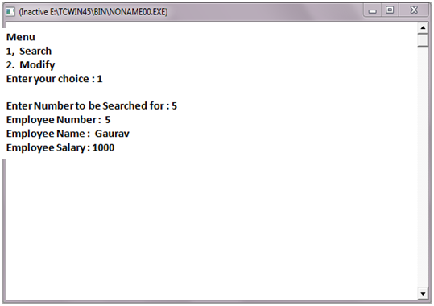

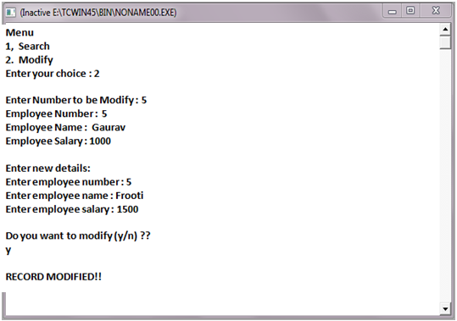

PRACTICAL 9...

/*Program to search a string in file */

#include<iostream.h>

#include<fstream.h>

#include<stdio.h>

#include<string.h>

void main()

{

fstream f;

char ch[10],word[50];

cout<<"Enter string to be searched for : ";

gets(ch);

int count =0;

f.open("comp.txt",ios::in);

while (f)

{

f>>word;

if(strcmpi(word,ch)==0)

count++;

}

cout<<"The string ";

puts(ch)

cout<<"occurs "<<count<<" time/times in comp.txt file.";

}

Output 9

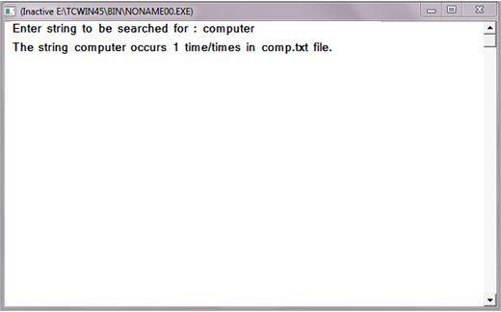

PRACTICAL 10...

/*Program to search a telephone directory*/

#include<iostream.h>

#include<fstream.h>

#include<stdio.h>

#include<process.h>

class Directory

{

char Name[20],Address[30],AreaCode[5];

long double Pno;

public:

void regis()

{

cout<<"Enter Name : \n";

gets(Name);

cout<<"Enter Address :\n";

gets(Address);

cout<<"Enter Area Code :\n";

gets(AreaCode);

cout<<"Enter Phone number :\n";

cin>>Pno;

}

void show()

{

cout<<" Name : \n";

puts(Name);

cout<<" Address :\n";

puts(Address);

cout<<"Area Code :\n";

puts(AreaCode);

}

float check()

{

return Pno;

}

};

void main()

{

Directory D;

fstream f;

f.open("Directory.txt",ios::in);

long double ch;

cout<<"Enter phone number u want to search for";

cin>>ch;

f.read((char*)&D,sizeof(D));

while(f)

{

 if(D.check()==ch)

 {

D.show();

 break;

}

else

f.read((char*)&D,sizeof(D));

}

 f.close();

}

Output 10

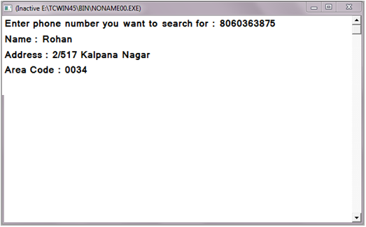

PRACTICAL 11...

/*Program to count number of spaces, digits, uppercase and lowercase letters in a file */

#include<iostream.h>

#include<fstream.h>

#include<ctype.h>

#include<string.h>

void main()

{

char ch;

int up=0,low=0,dig=0,spa=0;

fstream f;

f.open("File.txt",ios::in);

while(!f.eof())

{

f.get(ch);

if(isspace(ch))

spa++;

else if(islower(ch))

low++;

else if(isdigit(ch))

dig++;

else if(isupper(ch))

up++;

}

cout<<"No. of Upper case letters in file : "<<up<<endl;

cout<<"No.of lower case letters in file : "<<low<<endl;

cout<<"No. of Digits in file : "<<dig<<endl;

cout<<"No. of spaces in file : "<<spa<<endl;

f.close();

}

Output:

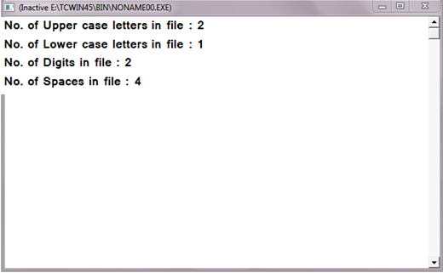

PRACTICAL 12...

/* Program to display frequency table of occurrence of alphabets in a  file */

#include<iostream.h>

#include<fstream.h>

void main()

{

char ch;

int a=0,b=0,c=0,d=0,e=0,f=0,g=0,h=0,i=0,j=0,k=0, l=0,m=0,n=0,o=0,p=0,q=0;

int r=0,s=0,t=0,u=0,v=0,w=0,x=0,y=0,z=0;

fstream f1;

f1.open("Alpha.txt",ios::in);

while(f1)

{

f1.get(ch);

switch(ch)

{

case 'A':

case 'a': a++;

break;

case 'B':

case 'b': b++;

break;

case 'C':

case 'c': c++;

break;

case 'D':

case 'd': d++;

break;

case 'E':

case 'e': e++;

break;

case 'F':

case 'f': f++;

break;

case 'G':

case 'g': g++;

break;

case 'H':

case 'h': h++;

break;

case 'I':

case 'i': i++;

break;

case 'J':

case 'j': j++;

break;

case 'K':

case 'k': k++;

break;

case 'L':

case 'l': l++;

break;

case 'M':

case 'm': m++;

break;

case 'N':

case 'n': n++;

break;

case 'O':

case 'o': o++;

break;

case 'P':

case 'p': p++;

break;

case 'Q':

case 'q': q++;

break;

case 'R':

case 'r': r++;

break;

case 'S':

case 's': s++;

break;

case 'T':

case 't': t++;

break;

case 'U':

case 'u': u++;

break;

case 'V':

case 'v': v++;

break;

case 'W':

case 'w': w++;

break;

case 'X':

case 'x': y++;

break;

case 'Y':

case 'y': x++;

break;

case 'Z':

case 'z': z++;

break;

}

}

cout<<"The number of occurrence of the characters is as follows : \n";

cout<<" A : "<<a<<"\t";

cout<<" B : "<<b<<"\t";

cout<<" C : "<<c<<"\t";

cout<<" D : "<<d<<"\t";

cout<<" E : "<<e<<"\n";

cout<<" F : "<<f<<"\t";

cout<<" G : "<<g<<"\t";

cout<<" H : "<<h<<"\t";

cout<<" I : "<<i<<"\t";

cout<<" J : "<<j<<"\n";

cout<<" K : "<<k<<"\t";

cout<<" L : "<<l<<"\t";

cout<<" M : "<<m<<"\t";

cout<<" N : "<<n<<"\t";

cout<<" O : "<<o<<"\n";

cout<<" P : "<<p<<"\t";

cout<<" Q : "<<q<<"\t";

cout<<" R : "<<r<<"\t";

cout<<" S : "<<s<<"\t";

cout<<" T : "<<t<<"\n";

cout<<" U : "<<u<<"\t";

cout<<" V : "<<v<<"\t";

cout<<" W : "<<w<<"\t";

cout<<" X : "<<x<<"\t";

cout<<" Y : "<<y<<"\n";

cout<<" Z : "<<z<<"\n";

f1.close();

}

Output 12

